

Dr. Nathan, Anderson inc.

2019-07-30

Dr. Anderson

10145 Anna Mount Suite 659, Lake Brandon, DC 55128

Phone: 4063984640

Fax: 3912130075

**Re:** Victoria, Weber

**PHN:** 6822756915

**Birthdate:** 30-Jan-1960

**Address:** 067 Bryant Loop, New Alexis, IA 74188

**Patient number:** 9569941212

To Whom It May Concern:

This is a medical letter to state the above patient is pregnant with expected delivery date of 16-Apr-2025. Hoping this information is satisfactory for your requirements.

Thank you.

Sincerely,

Dr. Nathan, Anderson

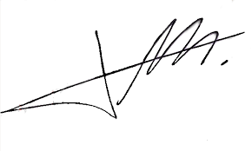

FRCS© NCMP

Clinical Assistant Professor, UBC

Department of Obstetrics and Gynecology SMH